Mask-Afr-Mali- Djenne Snake `

Mali-Djenne- Terracotta Sculpture of a Coiled Serpent - 5.11 inches, 1.48 pounds, ca. 1000 CE.

The terracotta representation of a serpent is attested to in a 1972 excavated site near Toguere Doupwil just outside Mopti which was a broken statuette encircled by a serpent (Sarr 1972:2-16) and funerary urns excavated five years later yielded dates of 960 ± 110 and 1015 ± 110 CE (Barth 1977).

The theme of the serpent often figures in the terracotta art of Djenne since serpent worship was important as an apotropaic or protective cult, or as the protection offered by the ancestors. It had none of the evil tones found in the Hebrew Bible. The wide-spread nature of the veneration of the serpent or serpent suggests that it may have not been unique to this region and may have been as ancient as the Sonike Empire of Wagadu who spoke Soninke, a Mande language and were the founders of the ancient empire of Ghana c. 750-1240 CE. In fact, the well-known Sonike epic of the founding of the Wagadu Empire mentions the sacrifice of a pregnant mare and a virgin gir to the serpent, Bida (Sylla 1977: part III, 6).

Sensitive and skillful artisans in the republic of Mali sculpted this intriguing image of a ceramic-coiled serpent. At the time of its creation the empire of West African Mali was at its zenith. The famous chronicler Ibn Battuta, a Berber theologian from Tangiers who spent a year in Mali, writes that he was overcome with amazement over the wealth of the Mansamusa court of Mali, whose splendor at the time was equal only to that of the Mongol empire (Hopkins and Levtzion 1981: 290). Djenne, one of the prospering cities at that time, also reaped the bounty of the rivers Niger and Bani, since it was strategically located at the confluence of these two waterways. An accessible and plentiful gift of the rivers was the ceramic grit, a material that was worked by local artisans in a skillful and creative fashion. The result of these efforts was the creation of terracotta sculptures that are truly distinguished in the world of ceramic art.

This terracotta serpent is a fascinating example of the Djenne artistry in this image of a coiled serpent. With a long body wrapped gracefully around it, the serpent rests his head atop his tail in a relaxing posture pose that belies his normally vigilant nature. Still visible on this serpent are the faint circular dots that once covered its surface probably to emulate a natural species.

Serpents commonly occur in the visual arts as well as in the oral traditions of numerous peoples of the inland delta region. Serpents play an important role in the cosmology and mythical origins of the clan. For example, serpents are king makers, designating the successful candidate by touching him with the nose (De Grunne 1980:17-35). Serpents are often considered to be symbols of immortality throughout sub-Saharan Africa because they "renew" themselves by shedding their skin (Parrinder 1954, 51). Serpents were venerated in the Mali culture, were used in the cult of ancestors and were linked symbolically with the idea of immortality since in the act of shedding their skins they are reborn. This serpentine work of art reflects that respect and admiration of the Djenne culture for the serpent through a combination of bold imagery and a sensitive spirit.

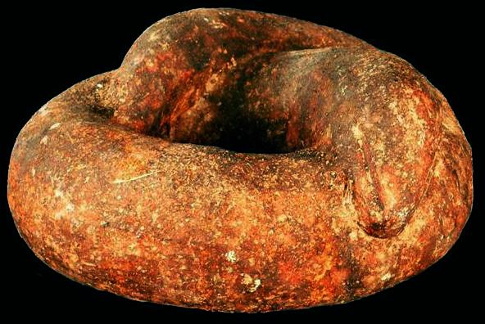

References:

Barth, H. K. 1977. Age de la civilisation des tumuliet des anciens habitants du delta intérier du Niger (Mali), *Notes Africaines*, July: 57-61.

De Grunne, Bernard. 1980. Terres Cuites Anciennes de L'ouest Africain. Louvain-la-Neuve : Institut supérieur d'archéologie et d'histoire de l'art, Collège Érasme.

Hopkins, J.E.P. and Levtzion, N. *Corpus of early Arabic sources for west African history.* Cambridge: Cambridge University Press.

Parrinder, Edward Geoffrey. 1954. *African traditional religion*. London, Hutchinson's University Library.

Sarr, M. La civilisation des togguérés dans la plaine de sevaré, *Études Maliennes*, May: 2-16.

Sylla, D. 1977. *L'Empire du Ghana, trans. M Soumare*. Paris: Fondation Scoa.

